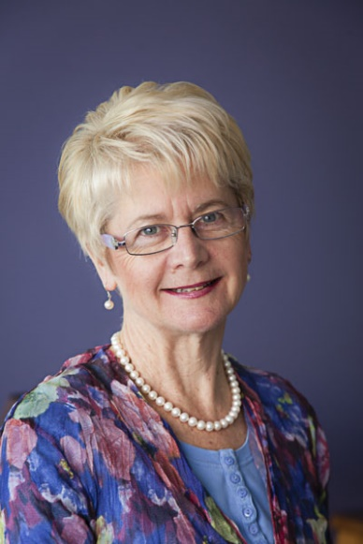
Lindy Clemson is Professor of Ageing and Occupational Therapy, director of the Ageing, Work & Health Research Group at the Faculty of Health Sciences and Leader of the Charles Perkins Centre Active Ageing Research Network, The University of Sydney, Australia and an investigator on the Centre of Excellence for Population Ageing Research (CEPAR).
Lindy is an international leader in research on enablement and environmental approaches to community-based fall prevention and nationally recognised as Australia’s leading occupational therapy researcher in Ageing (National Research Award 2013).
She has published over 170 peer-reviewed journal articles and has been awarded more than $64m in research funding. She is also one of only three other international fall trialists who have consistently been in the top 10 over the past decade (Web of Science) and the only one to develop three novel and successful fall prevention programs for older people, all implemented world-wide. She is now applying her skills in developing complex interventions and conducting complex trials to improve functional and behavioural outcomes for people with dementia and their carers living in the community.
Her work has influenced both policy and practice, and her publications are highlighted in Cochrane Reviews, the Australian and the US national fall prevention practice guidelines, and the US compendium of effective community-based falls prevention interventions. The broad and significant impact of her work is exemplified by the fact that the United States Centre for Disease Control chose her evidence-based Stepping On program (tested in a randomised trial and published in the Journal of the American Geriatrics Society, 2004) as one of only four programs to support for national implementation. Another of her enablement interventions (Lifestyle-Integrated Functional Exercise, LiFE), published in 2012 has already the focus of implementation studies in Australia, the US, Canada and Germany. LiFE is currently the core intervention in a large European Horizon grant PrevenIT (E4.6M) to develop the LiFE program for younger-older adults with the aim of improving functional capacity as the main outcome. She has always ensured interventions are translation-ready with practical outputs. Her fall prevention program manuals have achieved large sales worldwide, indicative of her ability to provide clear direction for implementation.
Her translation work now extends to implementation research with National Health and Medical Research (NHMRC) Partnership Projects developing and examining implementation and sustainability of community-based fall prevention activities at the population level. She was an invited member of the NHMRC 2016 committee to develop the National Practice Guidelines for Dementia and is a life member of the Independent Living Centre.

